

KWAME NKRUMAH UNIVERSITY OF SCIENCE AND TECHNOLOGY

COLLEGE OF ENGINEERING

DEPARTMENT OF CHEMICAL ENGINEERING

TITLE: ENTHALPY AND ENTROPY OF AN AQUEOUS BORAX SOLUTION

NAME: AMPAW-ASIEDU MERCY

COURSE: BSC. CHEMICAL ENGINEERING

YEAR: SECOND YEAR

EXPERIMENT NO. : P.1.2.2.

I.D. NO: 3643609

DEMONSTRATOR: NESTA BOTTEY-SAM
DATE: 2ND MARCH, 2011.

Aims and Objectives:
- To measure the enthalpy (∆H) and entropy (∆S) of an aqueous solution of borax (sodium tetraborate decahydrate) from the temperature dependence of the equilibrium constant for the dissolution reaction of borax in water.
- To study a system of an aqueous solution of borax.
- To become acquainted with the changes in free energy, enthalpy, and entropy and their relation to the equilibrium constant for a chemical reaction.

INTRODUCTION/THEORY
The system to be studied involves relatively simple solubility equilibrium of borax (Na2B4O7•10H2O) in water:

Na2B4O7 • 10H2O(s) <--=======--> 2Na+(aq) + B4O5(OH)42−(aq) + 8H2O(l)

The proper equilibrium expression for the reaction above has this form:

[Na+]2[B4O5(OH)42−] [H2O]8
K = __________________________
[Na2B4O7 • 10H2O]

The experimental procedure will specifically state that you are to make sure there is always some solid borax remaining in the sample mixture before you remove some of it to analyze. That being the case, the 'concentration' of solid borax can be assumed constant, and the equilibrium expression can be simplified:

K = [Na+]2 [B4O5(OH)42−] [H2O]8

The water term in the expression (which was originally part of borax's crystalline matrix) is lost to the sample mixture. This added amount of water does not significantly change the concentration of water already present. The water term can also be 'simplified out' of the equilibrium expression:

K = [Na+]2 [B4O5(OH)42−]

What remains is now a solubility product constant (Ksp) expression for borax in water. To determine a value for the solubility product, a method must be found to assay either the amount of sodium ion, or borate ion, in the sample mixture. The original equilibrium expression, and balanced solubility equilibrium reaction, leads to a convenient way to express either ion in terms of the other, so that it is possible to define Ksp in terms of either the concentration of sodium ion, or concentration of borate ion. A series of substitutions, based on the original balanced solubility equilibrium equation, gives the desired Ksp, expression defined in terms of the borate ion only:

[Na+] = 2 [B4O5(OH)42−]

K = [ (2 [B4O5(OH)42−] ) ]2 [B4O5(OH)42−]

Ksp = 4 [B4O5(OH)42−]3

Finding the concentration of borate ion, in any sample at any given temperature, leads directly to a value for solubility product (Ksp) at that temperature.
For a series of borax-containing samples taken at various temperatures, the concentration of borate ion will be determined. The borate ion reacts with monoprotic acid (such as HCl) in a 1:2 fashion:

B4O5(OH)42−(aq) + 2HCl(aq) + 3H2O(l) ----------> 4 B(OH)3(aq) + 2Cl− (aq)

The amount of HCl consumed (in L) multiplied by the molarity of the acid gives moles HCl. It is a trivial exercise to determine moles borate ion from there, and dividing by the volume of borate ion-containing sample in liters gives concentration of borate ion. This general procedure is repeated for borate ion-containing samples of constant volume obtained at various temperatures.

Calculation of these temperature-dependent values for Ksp of borate ion is but the first step in a greater sequence of obtaining complete thermodynamic parameters for the dissolution of borax in water.

There are several other important thermodynamic parameters that can be found: free energy change, enthalpy, and entropy, upon further treatment of the equilibrium constant/temperature base data set. The next goal will be to estimate the free energy change for this solubility equilibrium. The following equation immediately shows the relationship between free energy change (ΔG) and equilibrium constant (K):

ΔG = −RT ln Ksp (A)

A value for the equilibrium constant at a given temperature gives (after a sense) the value for free energy change directly. The free energy change at a given temperature is itself related to both the change in enthalpy, and the change in entropy, by the following equation:

ΔG = ΔH − TΔS (B)

Combining the two equations relates K, ΔH, and ΔS in a single statement:

−RT ln Ksp = = ΔH − TΔS
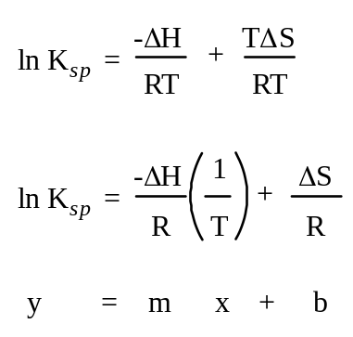
The preceding equation can be rearranged into a form that is linear. When re-arranged into a linear form, 1/T and ln Ksp can be used as (x, y) points on a graph. The slope of such a graph is related to the change in enthalpy and the change in entropy is related to the y-intercept:

A summary of the post-data collection activities reveals the true beauty of this experiment. Once the solubility product constants have been determined for 5 different temperatures,
• A table of free energy values (ΔG) with the temperatures those values correspond to should be compiled. This is most conveniently done using equation (A), with values for Ksp and the temperatures for which they are valid.
• A graph of ln Ksp vs. 1/T should be made, the slope of which is related to change in enthalpy.
• The same graph has a relationship between change in entropy and its y-intercept

The experiment requires that the solubility of borax be found at various temperature values. Samples of saturated borax solution are collected at no less than 5 different temperatures, four above room temperature, and one close to or at room temperature. These samples are then warmed (if necessary) to re-dissolve any precipitated borax, and titrated to the yellow bromocresol green endpoint with standardized aqueous hydrochloric acid.

EXPERIMENTAL APPARATUS AND CHEMICAL
- Erlenmeyer flask.
- Test tubes
- 50.00ml Burette
- Pipette
- Laboratory thermometer.
- Burner
- 100.00ml beaker.
- Digital analytical balance

PROCEDURE

Procedure | Observation
- 5 clean test tubes were labeled and 5.00ml of water was transferred into each test tube with a volumetric pipette.
- The exact level of the liquid in the test tube was marked after which the liquid was discarded and the test tube dried.
- Approximately 30g of borax was dissolved in a 100mL beaker in 50mL of distilled water. | Not all the borax dissolved.  Formation of a white chalky mixture.
- The mixture was then heated gently to 65ºC and a little more borax was added to the solution until excess solid was present and the solution was completely saturated.
- The solution was allowed to cool to approximately 60ºC and was poured into the test tube #1 until the level of the solution reached the exact 5.00mL mark on the test tube. The exact temperature of the solution was noted.
- The solution was allowed to cool to approximately 50ºC and exactly 5.00mL of it was poured into test tube #2. The exact temperature of the solution temperature was noted.
- The steps were repeated and the solution was cooled to approximately 40ºC, 30ºC and 20ºC in the tubes #3, #4 and #5 respectively.
- The contents of test tube #1 were transferred into a clean 125mL Erlenmeyer flask and the test tube was rinsed with several portions of distilled water, adding the rinse to the flask.
- Water was added to the crystallized solid remains in the test tube, and was heated gently until the borax dissolved and then transferred to the flask.
- 2 to 3 drops of bromocresol green indicator was added to the flask. | The colour of the bromocresol green was blue.
- A clean 50mL burette was filled with 0.5M HCl solution.
- A few mL of the acid was drained into an empty beaker and 1 drop of the bromocresol green was added to the acid.
- The content of the beaker was titrated to the end point with the HCl solution. | A light yellow colour was formed.
- The steps were repeated and the contents of each remaining test tube were titrated.

TABLE OF RESULTS

Temperature /ºC | Volume B₄O₅(OH)₄⁵⁻/ml | Volume HCl/ml
60 | 5.00 | 26.20
50 | 5.00 | 17.20
40 | 5.00 | 8.20
30 | 5.00 | 5.20
20 | 5.00 | 3.70

CALCULATIONS

Temp (ºC) | T (Kelvin) | 1/T | [Borate] | K_{sp} | InK_{sp}
60 | 333 | 3.003 x 10⁻³ | 1.31 | 8.99 | 2.20
50 | 323 | 3.096 x 10⁻³ | 0.86 | 2.54 | 0.93
40 | 313 | 3.195 x 10⁻³ | 0.41 | 0.28 | -1.29
30 | 303 | 3.300 x 10⁻³ | 0.26 | 0.07 | -2.66
20 | 293 | 3.413 x 10⁻³ | 0.185 | 0.025 | -3.68

At T = 60ºC = 273 + 60 = 333K
T⁻¹ = 333⁻¹ = 3.003 × 10⁻³ K⁻¹
From reaction equation: B4O5(OH)42−(aq) + 2HCl(aq) + 3H2O(l) ---------- 4B(OH)3(aq) + 2Cl− (aq)

n (borate) =1
n (H⁺) 2

n(borate) = 0.5 × n (H⁺)

n(H⁺) = [H⁺] × volume of H⁺
= 0.5 × 26.20/1000
= 0.0131mol

Hence n (borate) = 0.5 × 0.0131 mol
= 6.55×10⁻³mol
C= n/v
Concentration of borax, C ((B₄O₅(OH)₄⁵) = 6.55×10⁻³mol/0.005dm³
= 1.31M

K_{sp} = 4 [borate] ³
= 4 (1.31)³
= 8.99

InK_{sp} = 2.20

At T = 50ºC = 273 + 50 = 323K
T⁻¹ = 323⁻¹ = 3.096 × 10⁻³ K⁻¹
From reaction equation: B4O5(OH)42−(aq) + 2HCl(aq) + 3H2O(l) ---------->4B(OH)3(aq) + 2Cl− (aq)

n (borate) =1
n (H⁺) 2

n(borate) = 0.5 × n (H⁺)

n(H⁺) = [H⁺] × volume of H⁺
= 0.5 × 17.20/1000
= 8.6×10⁻³mol

Hence n (borate) = 8.6×10⁻³ mol×0.5
= 4.3×10⁻³mol
C= n/v
Concentration of borax, C ((B₄O₅(OH)₄⁵) = 4.3×10⁻³mol/0.005dm³
= 0.86M

K_{sp} = 4 [borate] ³
= 4 (0.86)³
= 2.54

InK_{sp} = 0.93

At T = 40ºC = 273 + 40 = 313K
T⁻¹ = 313⁻¹ = 3.195 × 10⁻³ K⁻¹
From reaction equation: B4O5(OH)42−(aq) + 2HCl(aq) + 3H2O(l) ---------->4B(OH)3(aq) + 2Cl− (aq)

n (borate) =1
n (H⁺) 2

n(borate) = 0.5 × n (H⁺)

n(H⁺) = [H⁺] × volume of H⁺
= 0.5 × 8.20/1000
= 4.1×10⁻³mol

Hence n (borate) = 4.1×10⁻³ mol×0.5
= 2.05×10⁻³mol
C= n/v
Concentration of borax, C ((B₄O₅(OH)₄⁵) = 2.05×10⁻³mol/0.005dm³
= 0.41M

K_{sp} = 4 [borate] ³
= 4 (0.41)³
= 0.28

InK_{sp} = -1.29

At T = 30ºC = 273 + 30 = 303K
T⁻¹ = 303⁻¹ = 3.300 × 10⁻³ K⁻¹
From reaction equation: B4O5(OH)42−(aq) + 2HCl(aq) + 3H2O(l) ---------->4B(OH)3(aq) + 2Cl− (aq)

n (borate) =1
n (H⁺) 2

n(borate) = 0.5 × n (H⁺)

n(H⁺) = [H⁺] × volume of H⁺
= 0.5 × 5.20/1000
= 2.6×10⁻³mol

Hence n (borate) = 2.6×10⁻³ mol×0.5
= 1.3×10⁻³mol
C= n/v
Concentration of borax, C ((B₄O₅(OH)₄⁵) = 1.3×10⁻³mol/0.005dm³
= 0.26M

K_{sp} = 4 [borate] ³
= 4 (0.26)³
= 0.07

InK_{sp} = -2.66

At T = 20ºC = 273 + 20 = 293K
T⁻¹ = 293⁻¹ = 3.413 × 10⁻³ K⁻¹
From reaction equation: B4O5(OH)42−(aq) + 2HCl(aq) + 3H2O(l) ---------->4B(OH)3(aq) + 2Cl− (aq)

n (borate) =1
n (H⁺) 2

n(borate) = 0.5 × n (H⁺)

n(H⁺) = [H⁺] × volume of H⁺
= 0.5 × 3.70/1000
= 1.85×10⁻³mol

Hence n (borate) = 1.85×10⁻³ mol×0.5
= 9.25×10⁻⁴mol
C= n/v
Concentration of borax, C ((B₄O₅(OH)₄⁵) = 9.25×10⁻⁴mol/0.005dm³
= 0.185M

K_{sp} = 4 [borate] ³
= 4 (0.185)³
= 0.025

InK_{sp} = -3.68

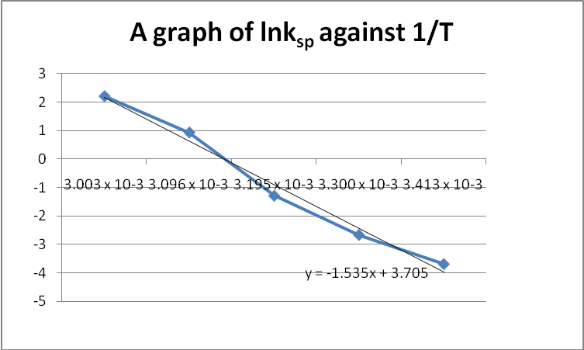

From graph, the equation of the line is y = -1.535x + 3.705

Gradient = Y₂ – Y₁
X₂ – X₁
= -14542.57

But from equation (2), slope = -ΔHº = - 14542.57
R

-ΔH = -14542.57R
R = 8.314J/molK

ΔHº = 8.314 x -14542.57
= 120.907KJ/molK

3. The two points are: (0.00305, 1.85),(0.00335,-2.1)

Gradient = Y₂ – Y₁
X₂ – X₁
= -13166.67

But from equation (2), slope = -ΔHº = -13166.67
R

-ΔH = -13166.67R
R = 8.314J/molK

ΔHº = 8.314 x -13166.67
= 109.468KJ/molK

Substituting into equation (2)

1.85 = -ΔHº (0.00305) + ΔS....... (1)
R R

But R = 8.314 J/mol and multiplying both sides by the value of ΔR and substituting the calculated value of ΔH, the value of ΔS is 15.715kJ/molK

- The value of the enthalpy of the dissociation of borax solution from the experiment conducted was
120.907kJ/mol. Comparing this value to the literature value (110 KJ/mol), it can be noticed that the value has deviated to an extent. This deviation can be attributed to certain factors:
- Temperature reading.
- Titre value obtained as a result of poor volume reading as a result of parallax.
- The nature of the borax solution (it solidifies quickly).
- Some of the solution clanged to the stirrer which was used as a result not all the 5.00ml borax solution was used in the titration.
- Recording the amount of acid used for titrating at very low temperatures was impossible due to the room temperature which was higher.

- The higher the solubility product, the more soluble the solid, from the experiment conducted and the values obtained, it is realized that as the temperature increased, there was an increase in solubility as indicated by the K_{sp} values and their corresponding temperatures.

On the other hand, when the temperature was decreasing, the borax solution was observed to be solidifying indicating also that a decrease in temperature reduces the solubility. In effect, there is a linear relationship between temperature and solubility.

- The positive value of ΔHº obtained signifies an endothermic reaction. It was also observed during the c experiment that when the solution was left standing for some time, it precipitated implying an endothermic process taking place.

- From the calculated value, the entropy of the system is positive. This is so because the entropy of the borax (initial state) is lower than the borax solution (final state). In the reaction, the reactants and products are of the same phase but the number of moles of the products is greater than the number of moles of the reactants which leads to an increase in entropy (positive).

DISCUSSION
From the experimental value, the enthalpy and entropy values are both positive and this imply by substitution that the Gibb’s free energy is positive.
A positive free energy imply that the dissolution of borax in distilled water is not spontaneous and will require external source of energy(endothermic) for complete dissolution thus the heating at different temperatures were done.

In comparing the experimentally derived values of enthalpy with that of the literature values, it is obvious that some major errors were made some of which are listed above. The solubility of the borate ion depends on temperature such that it increases as temperature increases. When equilibrium is established in the saturated solution at a specific temperature, the rate of formation of borate ions is equal to the rate of deposition of the borax.
It was observed during the course of the experiment that beaker was cold to touch until heating and when left standing when the borax was dissolved in water, the system caked and became cold implying an exothermic process taking place.

PRECAUTION
- The volumetric pipette was never used with heated solutions.
- The exact level of the liquid on the test tube to ensure accuracy.
- It was ensured that the solid borax was not transferred from the beaker to the test tube.

CONCLUSION
The higher the solubility product, the more soluble the solid, from the experiment conducted and the values obtained, it is realized that as the temperature increased, there was an increase in solubility as indicated by the K_{sp} values and their corresponding temperatures. This showed that solubility product of solids is highly dependent on temperature.
On the other hand, when the temperature was decreasing, the borax solution was observed to be solidifying indicating also that a decrease in temperature reduces the solubility. In effect, there is a linear relationship between temperature and solubility. The positive value of ΔHº obtained signifies an endothermic reaction.

Bromocresol green as an indicator turn yellow in an acidic region of 3.6-5.2. The colour of the solution changed to light yellow indicating the end point of the reaction. This shows that the indicator was suitable for the experiment.

REFFERENCES

- Chemistry the central science 7th edition by Brown Lemay Bursten (Page 597-8)
- CHEMISTRY: The Molecular Nature of Matter and Change by Martin Silberberg
- Laboratory manual,KNUST, Department of chemistry Exp P.1.2.2

AMPAW-ASIEDU MERCY
3643609
CHEMICAL ENG II
NESTA BOTTEY-SAM
2ND MARCH 2011

TABLE OF RESULTS FOR OXALATE

Temperature /ºC | Volume C₂O₄²⁻/ml | Volume MnO⁴⁻/ml
20 | 5.00 | 1.05
40 | 5.00 | 1.26
60 | 5.00 | 1.65
80 | 5.00 | 2.00

CALCULATIONS

Temp (ºC) | T (Kelvin) | 1/T | [Oxalate] | K_{sp} | InK_{sp}
20 | 293 | 3.413 x 10⁻³ | 5.46 x 10⁻⁵ | 2.981 x 10⁻⁹ | -19.63
40 | 313 | 3.195 x 10⁻³ | 6.553 x 10⁻⁵ | 9.290 x 10⁻⁹ | -19.27
60 | 333 | 3.003 x 10⁻³ | 8.58 x 10⁻⁵ | 7.360 x 10⁻⁹ | -18.73
80 | 353 | 2.833 x 10⁻³ | 1.04 x 10⁻⁴ | 1.0816 x 10⁻⁸ | -18.34

At T = 20ºC = 273 + 20 = 293K
T⁻¹ = 293⁻¹ = 3.413 × 10⁻³ K⁻¹
From reaction equation: 16H⁺(aq) + 5C2O4²⁻(aq) + 2MnO⁴⁻(aq) ------------------ 10CO2(aq) + 2Mn²⁺(aq) +8H2O(l)
n (oxalate) =5
n (MnO⁴⁻) 2

n(oxalate) = 2.5 × n (MnO⁴⁻)

n(MnO⁴⁻)= [MnO⁴⁻] × volume of MnO⁴⁻
= 1.04×10⁻⁴ × 1.05/1000
=1.092×10⁻⁷ mol

Hence n (oxalate) = 2.5 × 1.092×10⁻⁷ mol
= 2.73×10⁻⁷mol
C= n/v
Concentration of oxalate, C = 2.73×10⁻⁷ mol/0.005dm³
= 5.46×10⁻⁵M

K_{sp} = [oxalate]²
= (5.46×10⁻⁵)²
= 2.981×10⁻⁹

InK_{sp} = -19.63

At T = 40ºC = 273 + 40 = 313K
T⁻¹ = 313⁻¹ = 3.195 × 10⁻³ K⁻¹
From reaction equation: 16H⁺(aq) + 5C2O4²⁻(aq) + 2MnO⁴⁻(aq) ------------------ 10CO2(aq) + 2Mn²⁺(aq) +8H2O(l)
n (oxalate) =5
n (MnO⁴⁻) 2

n(oxalate) = 2.5 × n (MnO⁴⁻)

n(MnO⁴⁻)= [MnO⁴⁻] × volume of MnO⁴⁻
= 1.04×10⁻⁴ × 1.26/1000
=1.3104×10⁻⁷ mol

Hence n (oxalate) = 2.5 × 1.3104×10⁻⁷ mol
= 3.276×10⁻⁷mol
C= n/v
Concentration of oxalate, C = 3.276×10⁻⁷ mol/0.005dm³
= 6.552×10⁻⁵M

K_{sp} = [oxalate]²
= (6.552×10⁻⁵)²
= 4.29×10⁻⁹

InK_{sp} = -19.27

At T = 60ºC = 273 + 60 = 333K
T⁻¹ = 333⁻¹ = 3.003 × 10⁻³ K⁻¹
From reaction equation: 16H⁺(aq) + 5C2O4²⁻(aq) + 2MnO⁴⁻(aq) ------------------ 10CO2(aq) + 2Mn²⁺(aq) +8H2O(l)
n (oxalate) =5
n (MnO⁴⁻) 2

n(oxalate) = 2.5 × n (MnO⁴⁻)

n(MnO⁴⁻)= [MnO⁴⁻] × volume of MnO⁴⁻
= 1.04×10⁻⁴ × 1.65/1000
=1.716×10⁻⁷ mol

Hence n (oxalate) = 2.5 × 1.716×10⁻⁷ mol
= 4.29×10⁻⁷mol
C= n/v
Concentration of oxalate, C = 4.29×10⁻⁷ mol/0.005dm³
= 8.58×10⁻⁵M

K_{sp} = [oxalate]²
= (8.58×10⁻⁵)²
= 7.36×10⁻⁹

InK_{sp} = -18.73

At T = 80ºC = 273 + 80 = 353K
T⁻¹ = 353⁻¹ = 2.833 × 10⁻³ K⁻¹
From reaction equation: 16H⁺(aq) + 5C2O4²⁻(aq) + 2MnO⁴⁻(aq) ------------------ 10CO2(aq) + 2Mn²⁺(aq) +8H2O(l)
n (oxalate) =5
n (MnO⁴⁻) 2

n(oxalate) = 2.5 × n (MnO⁴⁻)

n(MnO⁴⁻)= [MnO⁴⁻] × volume of MnO⁴⁻
= 1.04×10⁻⁴ × 2.0/1000
=2.08×10⁻⁷ mol

Hence n (oxalate) = 2.5 × 2.08×10⁻⁷ mol
= 5.2×10⁻⁷mol
C= n/v
Concentration of oxalate, C = 5.2×10⁻⁷ mol/0.005dm³
= 1.04×10⁻⁴M

K_{sp} = [oxalate]²
= (1.04×10⁻⁴)²
= 1.0816×10⁻⁸

InK_{sp} = -18.34

A GRAPH OF ln K_{sp} AGAINST 1/T

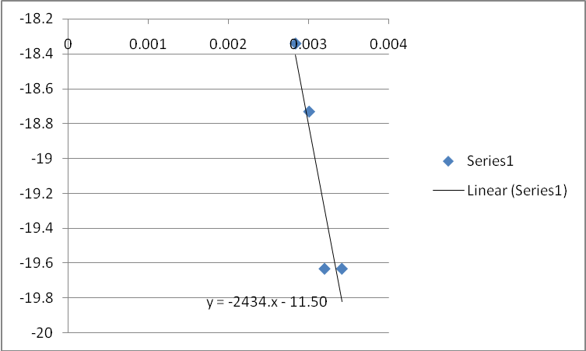

From graph, the equation of the line is y = -2434x + -11.50

Gradient = Y₂ – Y₁
X₂ – X₁
= -31.94

But from equation (2), slope = -ΔHº = -31.94
R

-ΔH =-31.94R
R = 8.314J/molK

ΔHº = 8.314 x 31.94
= 265.55KJ/molK

The point is: (0.003413, -19.63),
Substituting into equation (2)

-19.63 = -ΔHº (0.003413) + ΔS....... (1)
R R

But R = 8.314 J/mol and multiplying both sides by the value of ΔR and substituting the calculated value of ΔH, the value of ΔS is -162.31kJ/molK

DISCUSSION
It can be deduced from the results that the ΔS and ΔH are exothermic reactions and hence emit heat,the reason they were not performed in the laboratory.
SOURCE OF ERROR
Since the theoretical method was used the error might be small or not at all.

